Technical Learning Report: Week 2 Day 2
- Date: September 9, 2026
- Intern Name: Shekhar Singh Rawal
- Subject: Black-Box Test Techniques

1. Objective
The objective of the day was to understand and apply black-box test design techniques, particularly Equivalence Partitioning (EP), Boundary Value Analysis (BVA), Decision Table Testing, and State Transition Testing. The session focused on deriving a smaller but effective set of test cases by identifying valid and invalid input groups, important boundary values, combinations of business conditions, and different system states. Additional self-exploration was done on White-Box Testing and Experience-Based Testing.

2. Technical Breakdown

A. Black-Box Testing
Black-box testing was studied as testing performed without looking at the internal code or implementation of the system. The focus is on the inputs and outputs of the application.
Example from notes: Testing a vending machine by putting in money, pressing a button, and checking whether the correct snack is returned without considering its internal implementation.

B. Equivalence Partitioning (EP)
Equivalence Partitioning groups similar inputs together so that one representative value can be tested from each group.
Example from notes: If an application accepts an age from 1–100, instead of testing every possible age, representative values can be selected from different groups such as:
- Invalid low value: -5
- Valid value: 25
- Invalid high value: 150
For a phone-number field, the notes also identified partitions such as:
Partition | Example | Expected
Less than 10 | 974289622 | Invalid
Exactly 10 | 9742896227 | Valid
More than 10 | 97428622736 | Invalid
Non-numeric | 9AB72... | Invalid
Empty | Empty | Invalid

C. Boundary Value Analysis (BVA)
Boundary Value Analysis focuses on values at or around the limits of an input range because boundaries are important points for testing.
Example from notes: For a field where the phone number must contain exactly 10 digits, the boundary values considered were:
Boundary | Value | Expected
Below boundary | 9 | Invalid
Boundary | 10 | Valid
Above boundary | 11 | Invalid
Another example from the notes was a discount condition where an order must be above 500, leading to checking values around the boundary such as 499, 500, and 501.

D. Decision Table Testing
Decision Table Testing is useful when the system's output depends on multiple conditions.
Example from notes: A loan approval system checks:
- Income ≥ 250K
- Credit Score > 700
When both conditions are satisfied, the loan is approved; otherwise, it is rejected.
Another decision-table example in the notes used an ATM scenario with conditions such as:

ATM Decision Table Example:
Rule No. | Card Valid | PIN Correct | Enough Balance | Action
1 | Yes | Yes | Yes | Get Cash
2 | Yes | Yes | No | Show Insufficient Balance
3 | Yes | No | Yes | Show Incorrect PIN
4 | Yes | No | No | Show Incorrect PIN
5 | No | – | – | Show Invalid Card

Different combinations of these conditions lead to different actions, such as dispensing cash or displaying an appropriate message.

E. State Transition Testing
State Transition Testing checks how a system moves from one state to another when an event or action occurs.
A real example from the notes was an ATM flow:
Valid transition:
ATM Idle → Card Inserted → PIN Entered → Cash Dispensed
Invalid transition:
ATM Idle → Card Inserted → Incorrect PIN Entered 3 Times → Card Blocked
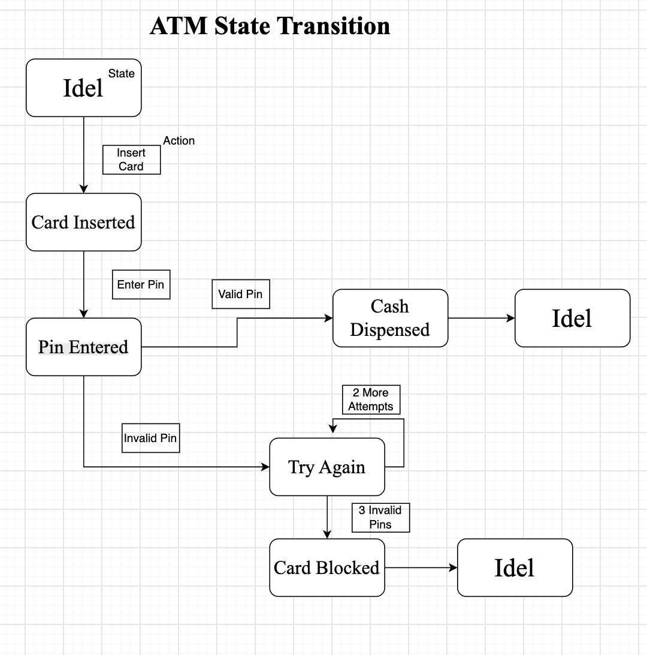

F. White-Box Testing — Self Exploration
White-box testing was explored separately as an additional topic. It focuses on the internal code, logic, structure, and flow of the program.
The notes covered:
Statement Testing
Checks that executable statements in the code are executed.
Example: If a function contains 10 executable lines, tests are designed so that all 10 lines are triggered.
Branch Testing
Checks different decision paths in the code, including both true and false outcomes.
Example:
if (age >= 18) → Allow Entry
The test should cover both:
- True branch → Allow entry
- False branch → Deny entry

G. Experience-Based Testing — Self Exploration
Experience-based testing was also explored independently.
It uses the tester's experience, intuition, knowledge, and lessons from past mistakes to identify possible problems.
The notes covered:
Error Guessing
The tester uses past experience to guess what is likely to cause a defect.
Example from the notes: An experienced tester may know that extra spaces are often accidentally entered at the end of an email field.
Exploratory Testing
The tester learns about the application while testing it without relying on a fixed script.
Example from the notes: Open a shopping application, click around, add and remove items, and try different combinations to discover what breaks.
Checklist-Based Testing
A tester uses a checklist built from previous experience to ensure important areas are checked.

3. Practical Implementation

A. EP and BVA Phone Number Exercise
The clear table combining Equivalence Partitioning (EP) and Boundary Value Analysis (BVA) for the phone-number field.
Equivalence Partitioning (EP)
Test Case | Input Category | Example Input | Expected Result
EP1 | Less than 10 digits | 123456789 | Invalid
EP2 | Exactly 10 digits | 1234567890 | Valid
EP3 | More than 10 digits | 12345678901 | Invalid
EP4 | Non-numeric input | abcdefghij | Invalid
EP5 | Empty input | Empty | Invalid
Boundary Value Analysis (BVA)
Test Case | Boundary Value | Example Input | Expected Result
BVA1 | Just below boundary | 9 digits | Invalid
BVA2 | Boundary value | 10 digits | Valid
BVA3 | Just above boundary | 11 digits | Invalid

This demonstrated how both techniques can reduce unnecessary test cases while still covering important input conditions.

B. Decision Table Exercise
A decision table was created using a business rule with multiple conditions.
The ATM example from the notes considered:
Rule | Card Valid | PIN Correct | Enough Balance | Action
1 | Yes | Yes | Yes | Get cash
2 | Yes | Yes | No | Show insufficient balance
3 | Yes | No | Yes | Show incorrect PIN
4 | No | – | – | Show invalid card
This demonstrated how combinations of conditions can be converted into specific test scenarios.

C. State Transition Diagram
A state transition diagram was created for an order lifecycle.
The main flow was:
Order Placed → Confirmed Order → Preparing → Ready for Pickup → Delivered
Alternative paths included cancellation resulting from payment failure, customer cancellation, or an order not being picked up.

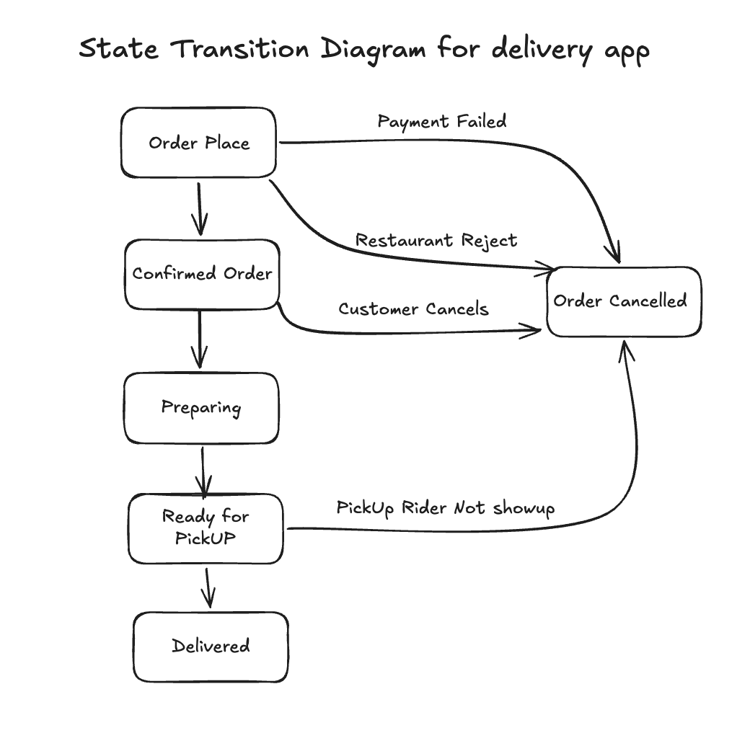

4. Key Findings & Best Practices
- Black-box testing focuses on system inputs and outputs without examining internal code.
- EP reduces testing effort by grouping similar inputs into partitions.
- BVA focuses specifically on important boundary values.
- Decision tables are useful when outcomes depend on multiple conditions.
- State Transition Testing is useful for workflows where the system moves between different states.
- Combining EP and BVA can provide useful coverage with fewer test cases.
- White-box testing considers internal code, logic, and execution paths.
- Statement Testing focuses on executing statements.
- Branch Testing focuses on different decision paths.
- Experience-based testing uses tester knowledge and previous experience to find likely problems.
- Error Guessing helps identify defects based on previous mistakes or common problem areas.
- Exploratory Testing allows the tester to learn and test the application at the same time.
- Checklist-based testing provides a structured list of areas to verify.

5. Conclusion
Day 2 of Week 2 focused primarily on Black-Box Test Techniques, including Equivalence Partitioning, Boundary Value Analysis, Decision Table Testing, and State Transition Testing. Practical exercises were completed using phone-number boundaries, multi-condition decision rules, and an order lifecycle.
Additional self-exploration covered White-Box Testing, Statement Testing, Branch Testing, and Experience-Based Testing, including Error Guessing, Exploratory Testing, and Checklist-Based Testing.

Glossary

Term | Definition | Example
Black-Box Testing | Testing software without looking at the internal code. | Enter a username and password and check if login works.
Equivalence Partitioning (EP) | Dividing inputs into groups and testing one value from each group. | For a 10-digit phone number, test 9, 10, and 11 digits.
Boundary Value Analysis (BVA) | Testing values at and around the limits. | For 10 digits, test 9, 10, and 11 digits.
Decision Table Testing | Testing different combinations of conditions. | Valid card + correct PIN + enough balance = cash is dispensed.
State Transition Testing | Testing how a system moves from one state to another. | Order Placed → Confirmed → Delivered.
White-Box Testing | Testing the internal code, logic, and paths. | Test both true and false conditions of an if statement.
Experience-Based Testing | Using tester experience to find possible defects. | Testing extra spaces in an email field.

